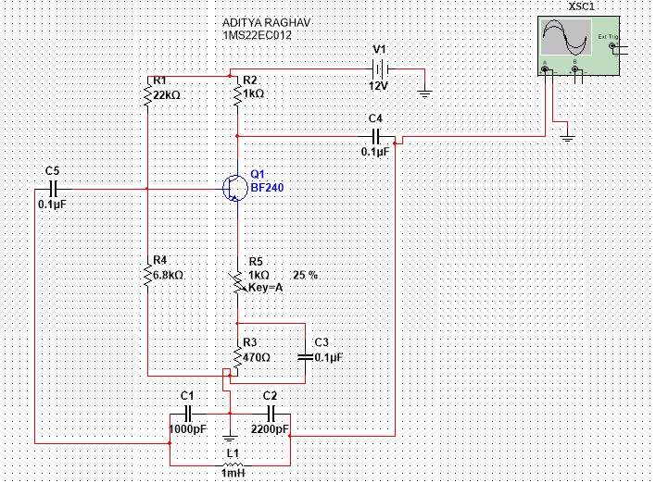

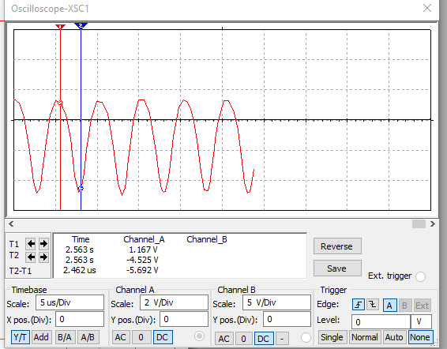
Timebase scale = 5us/div
Channel A scale =2v/div
Peak to peak amplitude of the output signal = 6.050v
Theoretical Frequency of Oscillator = 200KHz
Practical Frequency of Oscillator = 199KHz

