Big Data Analytics Laboratory

Sai Ashwin
1MS22CY061

Hadoop Programs
1. Write a MapReduce program to analyze the given natural numbers and generate statistics for the number as Odd or Even and print their sum.

driver.java

package oddeven;
import java.io.*;
import java.util.*;
import org.apache.hadoop.mapred.*;
import org.apache.hadoop.io.*;
import org.apache.hadoop.fs.Path;

public class driver
{
public static void main(String args[]) throws IOException
{
JobConf conf=new JobConf(driver.class);
conf.setMapperClass(mapper.class);
conf.setReducerClass(reducer.class);
conf.setOutputKeyClass(Text.class);
conf.setOutputValueClass(IntWritable.class);
FileInputFormat.addInputPath(conf, new Path(args[0]));
FileOutputFormat.setOutputPath(conf,new Path(args[1]));
JobClient.runJob(conf);
}
}

mapper.java

package oddeven;
import java.io.*;
import java.util.*;
import org.apache.hadoop.mapred.*;
import org.apache.hadoop.io.*;

public class mapper extends MapReduceBase implements Mapper<LongWritable , Text , Text , IntWritable>
{
public void map(LongWritable key,Text value,OutputCollector<Text,IntWritable> output,Reporter r) throws IOException
{
String[] line=value.toString().split(" ");
for(String num:line){
int number=Integer.parseInt(num);
if(number%2==0) {
output.collect(new Text("even"),new IntWritable(number));
}
else{
output.collect(new Text("odd"),new IntWritable(number));
}
}
}
}

reducer.java

package oddeven;
import java.io.*;
import java.util.*;
import org.apache.hadoop.mapred.*;
import org.apache.hadoop.io.*;
public class reducer extends MapReduceBase implements Reducer<Text,IntWritable,Text,IntWritable>
{
public void reduce(Text key,Iterator<IntWritable> value,OutputCollector<Text,IntWritable> output ,Reporter r) throws IOException
{
int sum=0,count=0;
while(value.hasNext()){
sum+=value.next().get();
count++;
}
output.collect(new Text("Sum of "+key+" Numbers"),new IntWritable(sum));
output.collect(new Text(key+" Number count"),new IntWritable(count));
}
}
oe.txt
1 2 3 4 5 6 7 8 9 10
Steps to run

1. Create a New File named Bash.sh
2. Copy the Below code and Paste inside Bash.sh and save that File.
export JAVA_HOME=$(readlink -f $(which javac) | awk 'BEGIN {FS="/bin"} {print
$1}')
export PATH=$(echo $PATH):$(pwd)/bin
export CLASSPATH=$(hadoop classpath)

3. Execute the bash.sh File using following command source Bash.sh.
4. Verify JAVA_HOME variable to be set to Java Path and PATH variable has your USN
Hadoop Folder.If any previous PATH set to Hadoop Folder remove that inside .bashrc
file.
5. Verify Hadoop is Installed or not by executing hadoop command.if command gives
Information about Hadoop command then Hadoop is Successfully Installed.
6. Create a folder oddeven and move to that folder
7. Make the driver.java , mapper.java and reducer.java files
8. Compile all java files (driver.java mapper.java reducer.java)
javac -d . *.java
9. Set driver class in manifest
echo Main-Class: oddeven.driver > Manifest.txt
10. Create an executable jar file
jar cfm oddeven.jar Manifest.txt oddeven/*.class
11. oe.txt is input file for Oddeven create Input File
echo 1 2 3 4 5 6 7 8 9 10 > oe.txt
12. Run the jar file
hadoop jar oddeven.jar oe.txt output
13. To see the Output
cat output/*

Output Screenshots

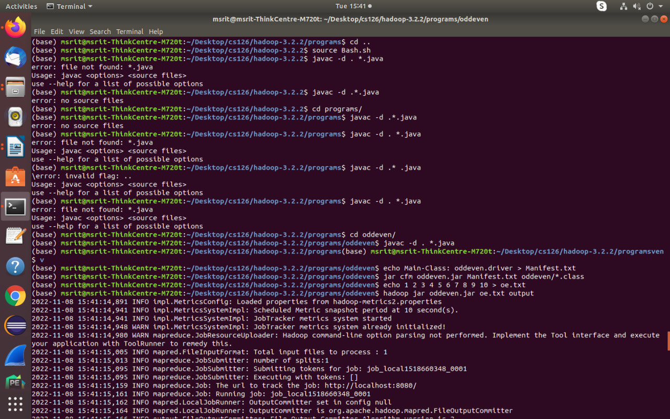

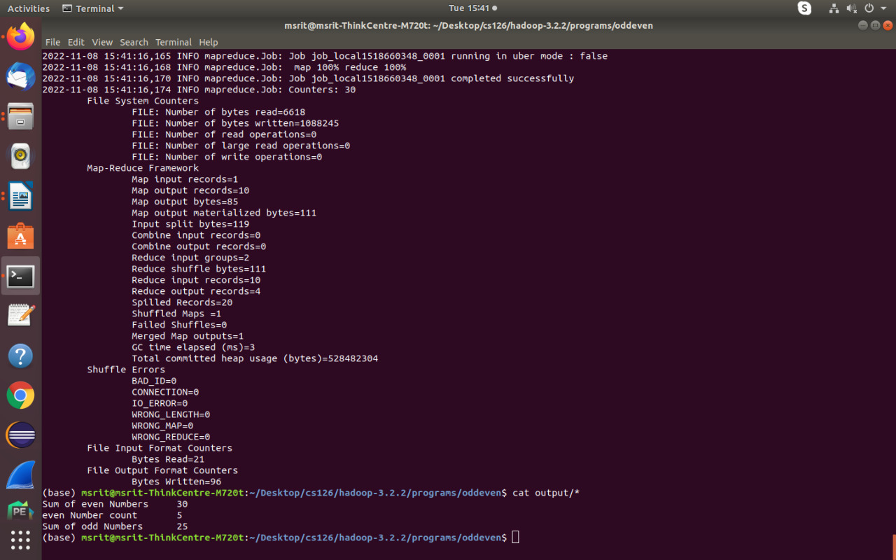

2. Write a MapReduce program to analyze the given Weather Report Data and to generate a report with cities having maximum and minimum temperature for a particular year.

driver.java

package weather;
import java.util.*;
import java.io.*;
import org.apache.hadoop.mapred.*;
import org.apache.hadoop.io.*;
import org.apache.hadoop.fs.Path;

public class driver
{
public static void main(String args[]) throws IOException
{
JobConf conf=new JobConf(driver.class);
conf.setMapperClass(mapper.class);
conf.setReducerClass(reducer.class);
conf.setOutputKeyClass(Text.class);
conf.setOutputValueClass(DoubleWritable.class);
FileInputFormat.addInputPath(conf, new Path(args[0]));
FileOutputFormat.setOutputPath(conf,new Path(args[1]));
JobClient.runJob(conf);
}
}

mapper.java

package weather;
import java.util.*;
import java.io.*;
import org.apache.hadoop.mapred.*;
import org.apache.hadoop.io.*;

public class mapper extends MapReduceBase implements Mapper<LongWritable, Text,Text,DoubleWritable>{
public void map(LongWritable key , Text value , OutputCollector<Text,DoubleWritable> output, Reporter r) throws IOException
{
String line=value.toString();
String year=line.substring(15,19);
Double temp=Double.parseDouble(line.substring(87,92));
output.collect(new Text(year), new DoubleWritable(temp));
}
}

reducer.java

package weather;
import java.util.*;
import java.io.*;
import org.apache.hadoop.mapred.*;
import org.apache.hadoop.io.*;
class reducer extends MapReduceBase implements Reducer<Text,DoubleWritable,Text,DoubleWritable> {
public void reduce(Text key, Iterator<DoubleWritable> value, OutputCollector<Text,DoubleWritable> output, Reporter r) throws IOException{
Double max=-9999.0;
Double min=9999.0;
while(value.hasNext()){
Double temp=value.next().get();
max=Math.max(max,temp);
min=Math.min(min,temp);
}
output.collect(new Text("Max temp at "+ key), new DoubleWritable(max));
output.collect(new Text("Min temp at "+ key), new DoubleWritable(min));
}
}

Input.txt

0067011990999991950051507004+68750+023550FM-12+038299999V0203301N00671220001CN9999999N9+00001+99999999999
0043011990999991950051512004+68750+023550FM-12+038299999V0203201N00671220001CN9999999N9+00221+99999999999
0043011990999991950051518004+68750+023550FM-12+038299999V0203201N00261220001CN9999999N9-00111+99999999999
0043012650999991949032412004+62300+010750FM-12+048599999V0202701N00461220001CN0500001N9+01111+99999999999
0043012650999991949032418004+62300+010750FM-12+048599999V0202701N00461220001CN0500001N9+00781+99999999999

Steps to run

1. Create a New File named Bash.sh
2. Copy the Below code and Paste inside Bash.sh and save that File.
export JAVA_HOME=$(readlink -f $(which javac) | awk 'BEGIN {FS="/bin"} {print
$1}')
export PATH=$(echo $PATH):$(pwd)/bin
export CLASSPATH=$(hadoop classpath)
3. Execute the bash.sh File using following command source Bash.sh.
4. Verify JAVA_HOME variable to be set to Java Path and PATH variable has your USN
Hadoop Folder.If any previous PATH set to Hadoop Folder remove that inside .bashrc
file.
5. Verify Hadoop is Installed or not by executing hadoop command.if command gives
Information about Hadoop command then Hadoop is Successfully Installed.
6. Create a folder weather and move to that folder
7. Make the driver.java , mapper.java and reducer.java files
8. Compile all java files (driver.java mapper.java reducer.java)
javac -d . *.java
9. Set driver class in manifest
echo Main-Class: weather.driver > Manifest.txt
10. Create an executable jar file
jar cfm oddeven.jar Manifest.txt weather/*.class
11. create input file input.txt
12. Run the jar file
hadoop jar weather.jar oe.txt output
13. To see the Output
cat output/*

Output Screenshots

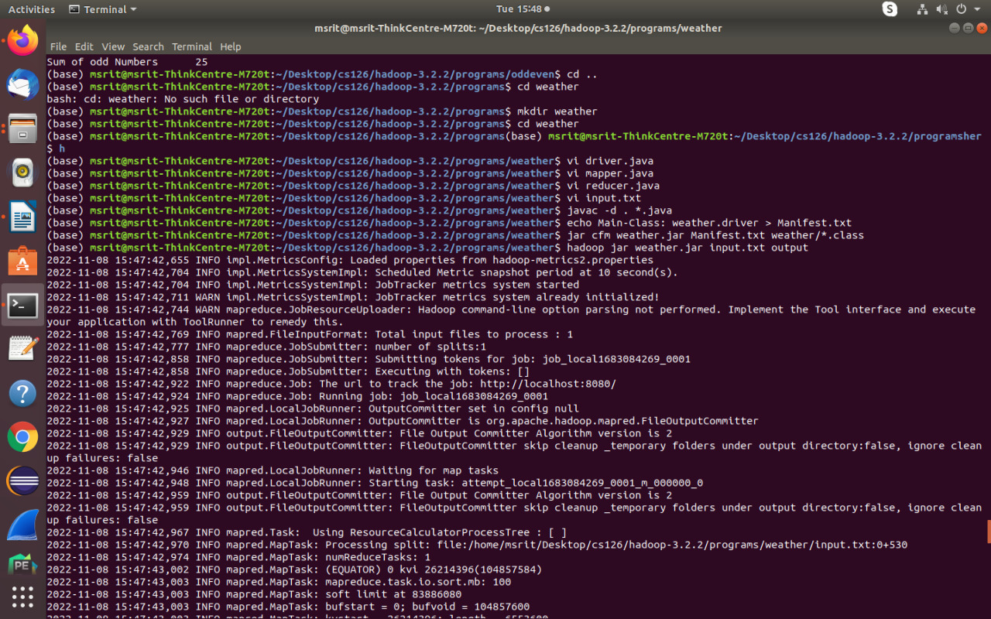
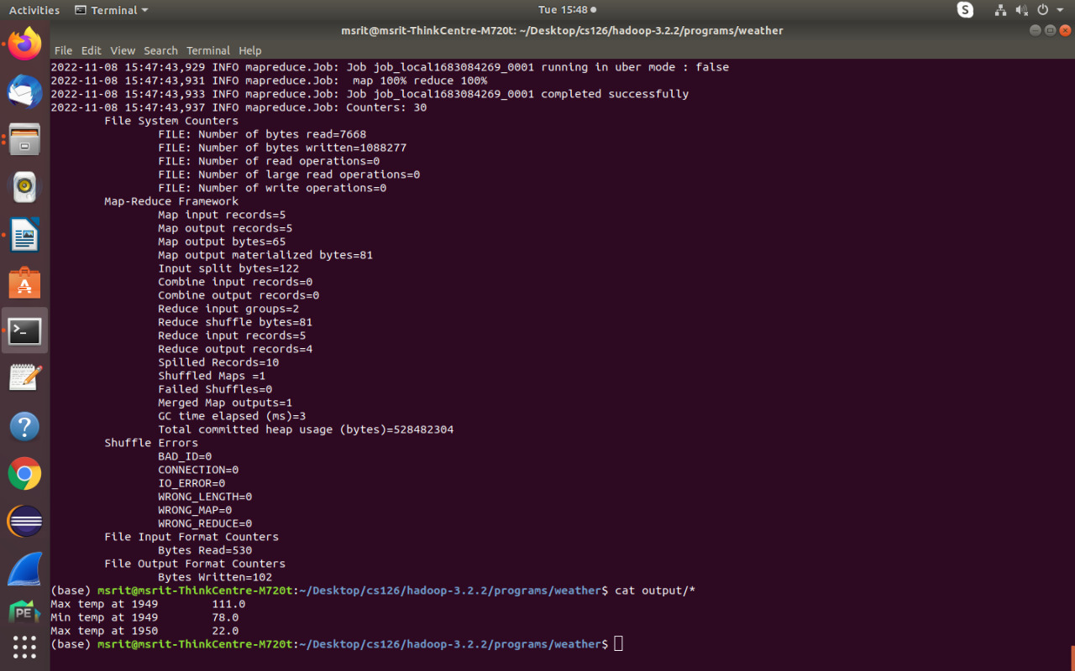

3. Write a MapReduce program to analyze the given Earthquake Data and
generate statistics with region and magnitude/ region and depth/ region and latitude/ region and longitude.

driver.java

package earthquake;
import java.util.*;
import java.io.*;
import org.apache.hadoop.mapred.*;
import org.apache.hadoop.io.*;
import org.apache.hadoop.fs.Path;

public class driver
{
public static void main(String args[]) throws IOException
{
JobConf conf=new JobConf(driver.class);
conf.setMapperClass(mapper.class);
conf.setReducerClass(reducer.class);
conf.setOutputKeyClass(Text.class);
conf.setOutputValueClass(DoubleWritable.class);
FileInputFormat.addInputPath(conf, new Path(args[0]));
FileOutputFormat.setOutputPath(conf,new Path(args[1]));
JobClient.runJob(conf);
}

mapper.java

package earthquake;
import java.util.*;
import java.io.*;
import org.apache.hadoop.mapred.*;
import org.apache.hadoop.io.*;
public class mapper extends MapReduceBase implements Mapper<LongWritable, Text,Text,DoubleWritable>
{
public void map(LongWritable key , Text value , OutputCollector<Text,DoubleWritable> output, Reporter r) throws IOException
{
String[] line=value.toString().split(",");
Double longi=Double.parseDouble(line[7]);
output.collect(new Text(line[11]), new DoubleWritable(longi));
}
}

reducer.java

package earthquake;
import java.util.*;
import java.io.*;
import org.apache.hadoop.mapred.*;
import org.apache.hadoop.io.*;
class reducer extends MapReduceBase implements Reducer<Text,DoubleWritable,Text,DoubleWritable> {

public void reduce(Text key, Iterator<DoubleWritable> value, OutputCollector<Text,DoubleWritable> output, Reporter r) throws IOException
{
Double max=-9999.0;
while(value.hasNext())
{
Double temp=value.next().get();
max=Math.max(max,temp);
}
output.collect(new Text(key), new DoubleWritable(max));
}

}

Steps to run

1. Create a New File named Bash.sh
2. Copy the Below code and Paste inside Bash.sh and save that File.
export JAVA_HOME=$(readlink -f $(which javac) | awk 'BEGIN {FS="/bin"} {print
$1}')
export PATH=$(echo $PATH):$(pwd)/bin
export CLASSPATH=$(hadoop classpath)

3. Execute the bash.sh File using following command source Bash.sh.
4. Verify JAVA_HOME variable to be set to Java Path and PATH variable has your USN
Hadoop Folder.If any previous PATH set to Hadoop Folder remove that inside .bashrc
file.
5. Verify Hadoop is Installed or not by executing hadoop command.if command gives
Information about Hadoop command then Hadoop is Successfully Installed.
6. Create a folder earthquake and move to that folder
7. Make the driver.java , mapper.java and reducer.java files
8. Compile all java files (driver.java mapper.java reducer.java)
javac -d . *.java
9. Set driver class in manifest
echo Main-Class: earthquake.driver > Manifest.txt
10. Create an executable jar file
jar cfm oddeven.jar Manifest.txt earthquake/*.class
11. create input file input.csv
12. Run the jar file
hadoop jar oddeven.jar input.csv output
13. To see the Output
cat output/*

Output Screenshots

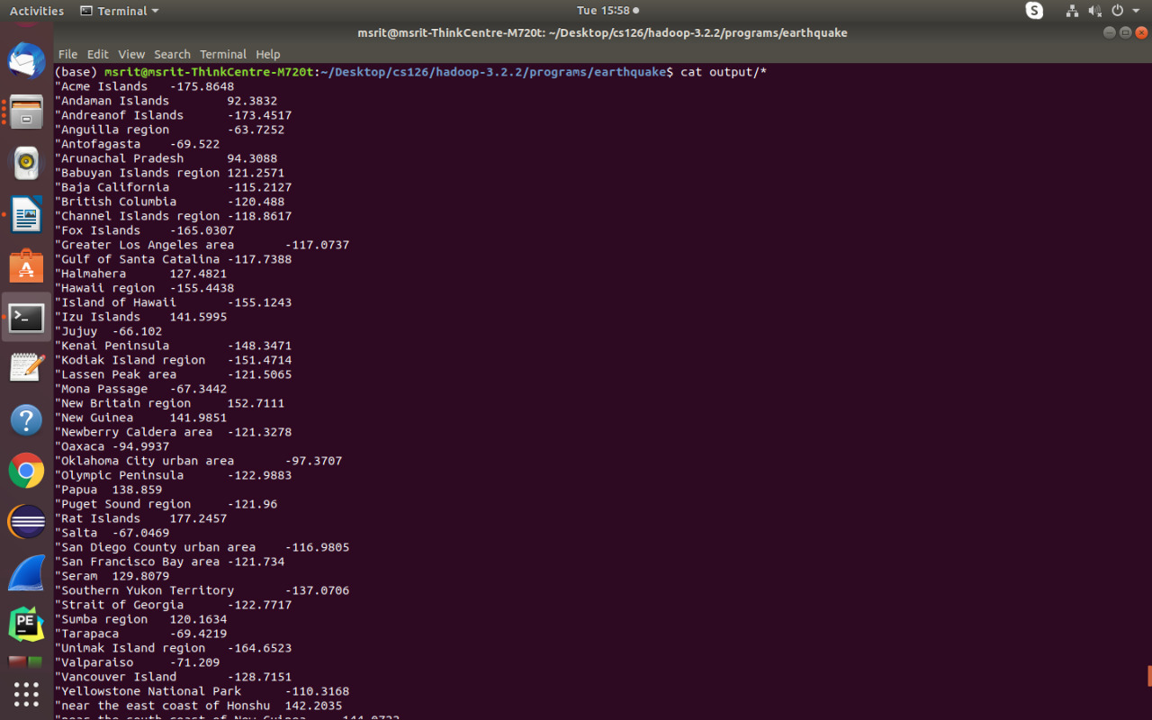
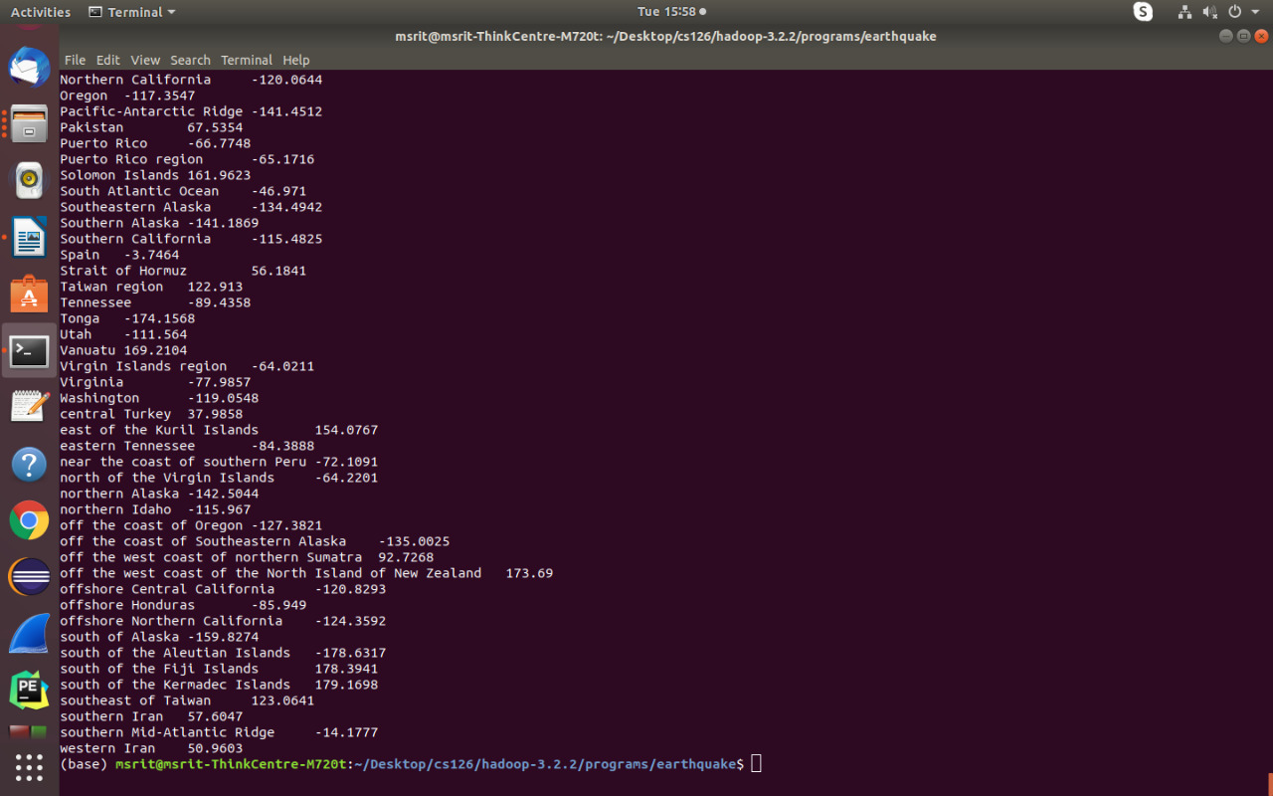

4. Write a MapReduce program to analyze the given Insurance Data and generate a statistics report with the construction building name and the count of building/county name and its frequency.

driver.java

package insurance;
import java.io.*;
import java.util.*;
import org.apache.hadoop.mapred.*;
import org.apache.hadoop.io.*;
import org.apache.hadoop.fs.Path;

public class driver
{
public static void main(String args[]) throws IOException
{
JobConf conf=new JobConf(driver.class);
conf.setMapperClass(mapper.class);
conf.setReducerClass(reducer.class);
conf.setOutputKeyClass(Text.class);
conf.setOutputValueClass(IntWritable.class);
FileInputFormat.addInputPath(conf, new Path(args[0]));
FileOutputFormat.setOutputPath(conf,new Path(args[1]));
JobClient.runJob(conf);
}
}

mapper.java

package insurance;
import java.io.*;
import java.util.*;
import org.apache.hadoop.mapred.*;
import org.apache.hadoop.io.*;

public class mapper extends MapReduceBase implements Mapper<LongWritable , Text , Text , IntWritable>
{
public void map(LongWritable key,Text value,OutputCollector<Text,IntWritable> output,Reporter r) throws IOException
{
String[] line=value.toString().split(",");
output.collect(new Text(line[2]),new IntWritable(1));
}
}

reducer.java

package insurance;
import java.io.*;
import java.util.*;
import org.apache.hadoop.mapred.*;
import org.apache.hadoop.io.*;
public class reducer extends MapReduceBase implements Reducer<Text,IntWritable,Text,IntWritable>
{
public void reduce(Text key,Iterator<IntWritable> value,OutputCollector<Text,IntWritable> output ,Reporter r) throws IOException
{
int sum=0;
while(value.hasNext())
{
sum+=value.next().get();
}
output.collect(key,new IntWritable(sum));
}
}

Steps to run

1. Create a New File named Bash.sh
2. Copy the Below code and Paste inside Bash.sh and save that File.
export JAVA_HOME=$(readlink -f $(which javac) | awk 'BEGIN {FS="/bin"} {print
$1}')
export PATH=$(echo $PATH):$(pwd)/bin
export CLASSPATH=$(hadoop classpath)

3. Execute the bash.sh File using following command source Bash.sh.
4. Verify JAVA_HOME variable to be set to Java Path and PATH variable has your USN
Hadoop Folder.If any previous PATH set to Hadoop Folder remove that inside .bashrc
file.
5. Verify Hadoop is Installed or not by executing hadoop command.if command gives
Information about Hadoop command then Hadoop is Successfully Installed.
6. Create a folder insurance and move to that folder
7. Make the driver.java , mapper.java and reducer.java files
8. Compile all java files (driver.java mapper.java reducer.java)
javac -d . *.java
9. Set driver class in manifest
echo Main-Class: insurance.driver > Manifest.txt
10. Create an executable jar file
jar cfm insurance.jar Manifest.txt insurance/*.class
11. Run the jar file
hadoop jar insurance.jar insurance.csv output
- Where insurance.csv is the input file
12. To see the Output
cat output/*

Output Screenshots

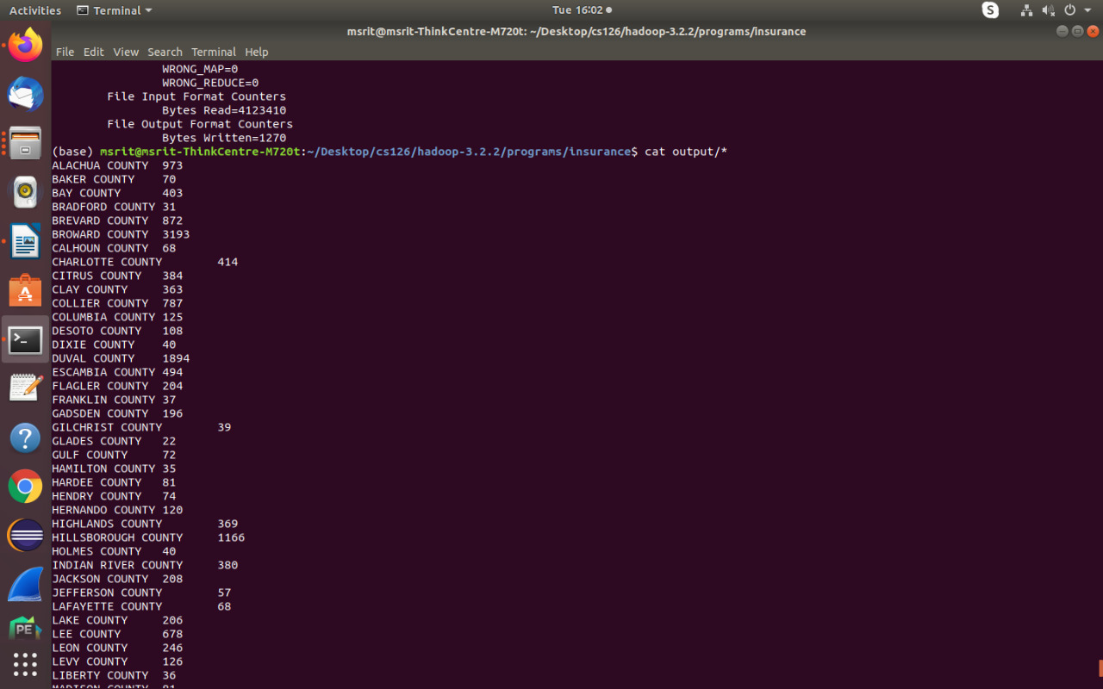
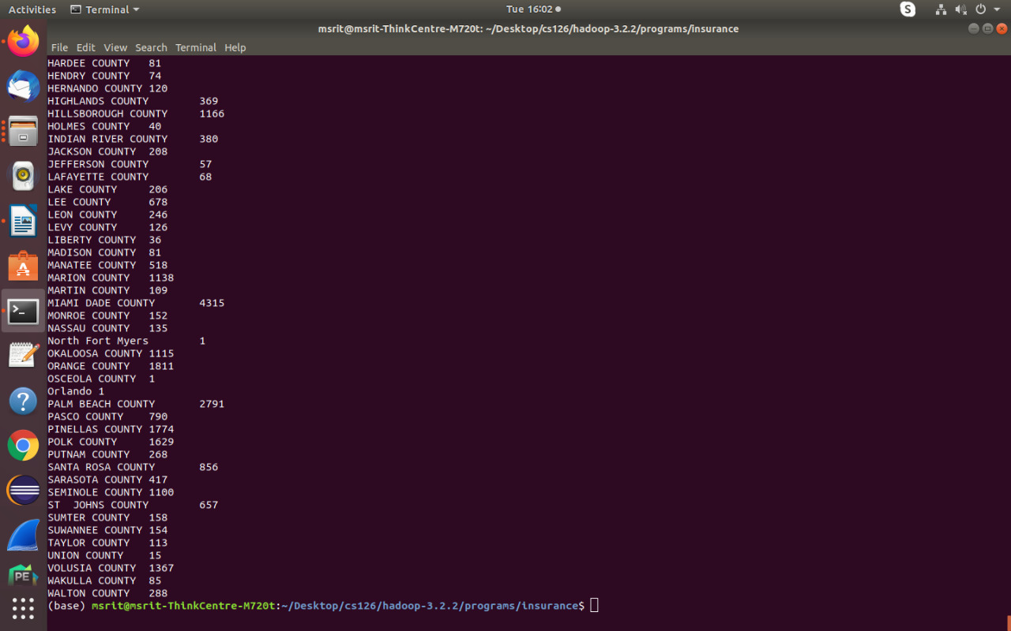

5. Write a MapReduce program using Java, to analyze the given Sales Records over a period of time and generate data about the country’s total sales, and the total number of the products. Country’s total sales and the frequency of the payment mode.

driver.java

package sales;
import java.io.*;
import java.util.*;
import org.apache.hadoop.mapred.*;
import org.apache.hadoop.io.*;
import org.apache.hadoop.fs.Path;

public class driver
{
public static void main(String args[]) throws IOException
{
JobConf conf=new JobConf(driver.class);
conf.setMapperClass(mapper.class);
conf.setReducerClass(reducer.class);
conf.setOutputKeyClass(Text.class);
conf.setOutputValueClass(IntWritable.class);
FileInputFormat.addInputPath(conf, new Path(args[0]));
FileOutputFormat.setOutputPath(conf,new Path(args[1]));
JobClient.runJob(conf);
}
}

mapper.java

package sales;
import java.io.*;
import java.util.*;
import org.apache.hadoop.mapred.*;
import org.apache.hadoop.io.*;

public class mapper extends MapReduceBase implements Mapper<LongWritable , Text , Text , IntWritable>
{
public void map(LongWritable key,Text value,OutputCollector<Text,IntWritable> output,Reporter r) throws IOException
{
String[] line=value.toString().split(",");
int price=Integer.parseInt(line[2]);
String cardtype=line[3];
String Country=line[7];
output.collect(new Text("Country "+Country),new IntWritable(price));
output.collect(new Text("CardType "+cardtype),new IntWritable(1));
}
}

reducer.java

package sales;

import java.io.*;
import java.util.*;
import org.apache.hadoop.mapred.*;
import org.apache.hadoop.io.*;

public class reducer extends MapReduceBase implements Reducer<Text,IntWritable,Text,IntWritable>
{
public void reduce(Text key,Iterator<IntWritable> value,OutputCollector<Text,IntWritable> output ,Reporter r) throws IOException
{
int sum=0;
while(value.hasNext())
{
sum+=value.next().get();
}
output.collect(new Text(key),new IntWritable(sum));
}
}

Steps to run

1. Create a New File named Bash.sh
2. Copy the Below code and Paste inside Bash.sh and save that File.
export JAVA_HOME=$(readlink -f $(which javac) | awk 'BEGIN {FS="/bin"} {print
$1}')
export PATH=$(echo $PATH):$(pwd)/bin
export CLASSPATH=$(hadoop classpath)

3. Execute the bash.sh File using following command source Bash.sh.
4. Verify JAVA_HOME variable to be set to Java Path and PATH variable has your USN
Hadoop Folder.If any previous PATH set to Hadoop Folder remove that inside .bashrc
file.
5. Verify Hadoop is Installed or not by executing hadoop command.if command gives
Information about Hadoop command then Hadoop is Successfully Installed.
6. Create a folder sales and move to that folder
7. Make the driver.java , mapper.java and reducer.java files
8. Compile all java files (driver.java mapper.java reducer.java)
javac -d . *.java
9. Set driver class in manifest
echo Main-Class: sales.driver > Manifest.txt
10. Create an executable jar file
jar cfm sales.jar Manifest.txt sales/*.class
11. Run the jar file
hadoop jar sales.jar SalesJan2009.csv output
- Where SalesJan2009.csv is the input file
12. To see the Output
cat output/*

Output Screenshots

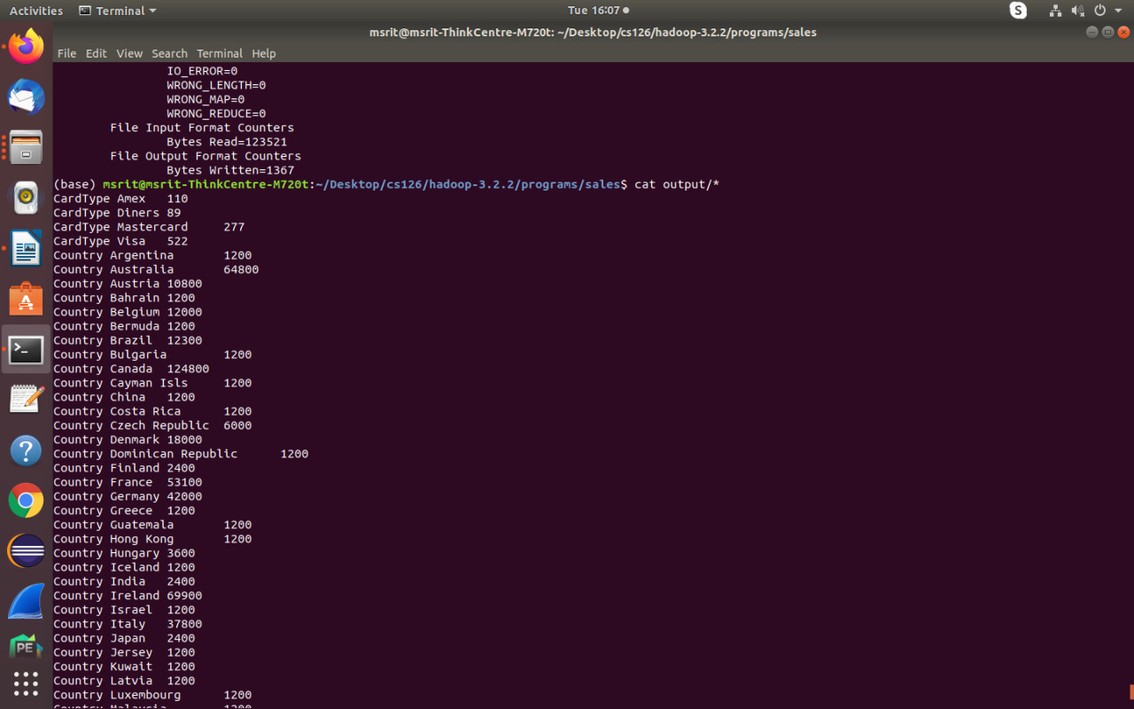

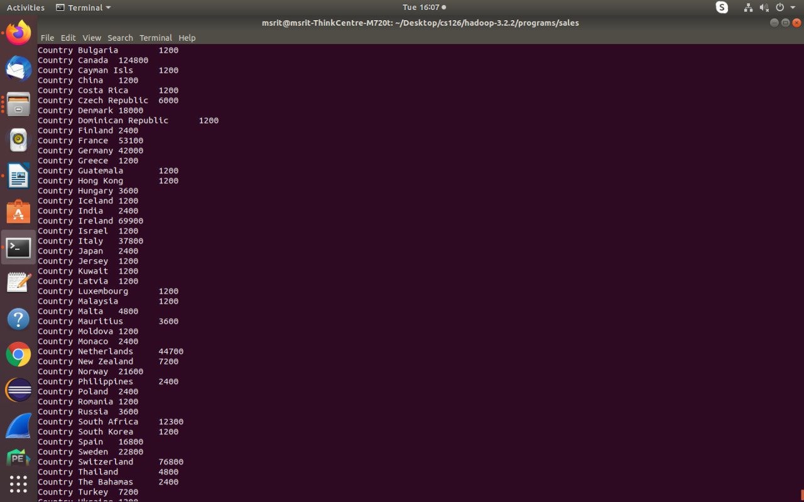

6. Write a MapReduce program using Java, to analyze the given employee record data and generate a statistics report with the total number of Female and Male Employees and their average salary.

driver.java

package employee;
import java.io.*;
import java.util.*;
import org.apache.hadoop.mapred.*;
import org.apache.hadoop.io.*;
import org.apache.hadoop.fs.Path;

public class driver
{
public static void main(String args[]) throws IOException
{
JobConf conf=new JobConf(driver.class);
conf.setMapperClass(mapper.class);
conf.setReducerClass(reducer.class);
conf.setOutputKeyClass(Text.class);
conf.setOutputValueClass(DoubleWritable.class);
FileInputFormat.addInputPath(conf,new Path(args[0]));
FileOutputFormat.setOutputPath(conf,new Path(args[1]));
JobClient.runJob(conf);
}
}

mapper.java

package employee;
import java.io.*;
import java.util.*;
import org.apache.hadoop.mapred.*;
import org.apache.hadoop.io.*;
class mapper extends MapReduceBase implements Mapper<LongWritable , Text , Text , DoubleWritable> {

public void map(LongWritable key, Text value, OutputCollector<Text,DoubleWritable> output ,Reporter r) throws IOException
{
String[] line=value.toString().split("\\t");
salary=Double.parseDouble(line[8]);
output.collect(new Text(line[3]), new DoubleWritable(salary));
}

}

reducer.java

package employee;
import java.io.*;
import java.util.*;
import org.apache.hadoop.mapred.*;
import org.apache.hadoop.io.*;
class reducer extends MapReduceBase implements Reducer<Text,DoubleWritable,Text,DoubleWritable> {
public void reduce(Text key,Iterator<DoubleWritable> value , OutputCollector<Text,DoubleWritable> output ,Reporter r) throws IOException
{
int count=0;
Double sum=0.0;
while(value.hasNext()){
sum+=value.next().get();
count+=1;
}
output.collect(new Text(key+" Average"), new DoubleWritable(sum/count));
output.collect(new Text(key+" Count"), new DoubleWritable(count));
}
}

Steps to run
1. Create a New File named Bash.sh
2. Copy the Below code and Paste inside Bash.sh and save that File.
export JAVA_HOME=$(readlink -f $(which javac) | awk 'BEGIN {FS="/bin"} {print
$1}')
export PATH=$(echo $PATH):$(pwd)/bin
export CLASSPATH=$(hadoop classpath)
3. Execute the bash.sh File using following command source Bash.sh.
4. Verify JAVA_HOME variable to be set to Java Path and PATH variable has your USN
Hadoop Folder.If any previous PATH set to Hadoop Folder remove that inside .bashrc
file.
5. Verify Hadoop is Installed or not by executing hadoop command.if command gives
Information about Hadoop command then Hadoop is Successfully Installed.
6. Create a folder employee and move to that folder
7. Make the driver.java , mapper.java and reducer.java files
8. Compile all java files (driver.java mapper.java reducer.java)
javac -d . *.java
9. Set driver class in manifest
echo Main-Class: employee.driver > Manifest.txt
10. Create an executable jar file
jar cfm employee.jar Manifest.txt employee/*.class
11. Run the jar file
hadoop jar employee.jar employee_records.txt output
- Where employee_records.txt is the input file
12. To see the Output
cat output/*

Output Screenshots

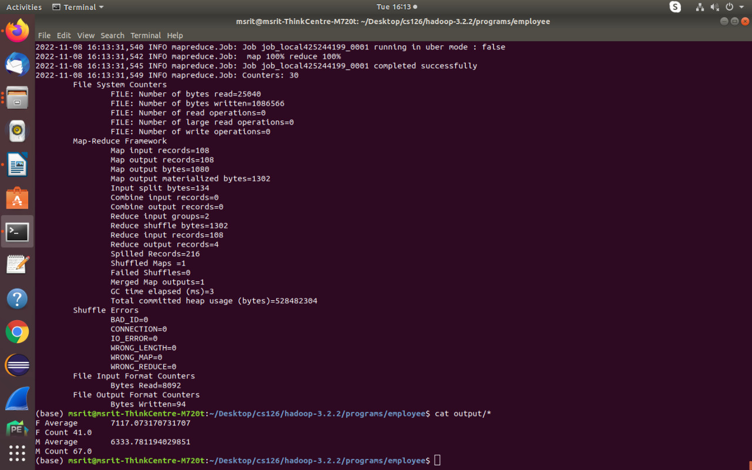

7. Matrix Multiplication

driver.java

package matrix;
import java.util.*;
import java.io.*;
import org.apache.hadoop.fs.Path;
import org.apache.hadoop.mapred.*;
import org.apache.hadoop.io.*;

public class driver{
public static void main(String args[]) throws IOException
{
JobConf conf=new JobConf(driver.class);
conf.setMapperClass(mapper.class);
conf.setReducerClass(reducer.class);
conf.setOutputKeyClass(Text.class);
conf.setOutputValueClass(Text.class);
FileInputFormat.addInputPath(conf,new Path(args[0]));
FileOutputFormat.setOutputPath(conf,new Path(args[1]));
JobClient.runJob(conf);

}
}

mapper.java

package matrix;
import java.util.*;
import java.io.*;
import org.apache.hadoop.mapred.*;
import org.apache.hadoop.io.*;
class mapper extends MapReduceBase implements Mapper<LongWritable, Text, Text,Text>
{
public void map(LongWritable key, Text value, OutputCollector<Text,Text> output, Reporter r) throws IOException
{
String line[]=value.toString().split(",");
Text OutputKey=new Text();
Text OutputValue=new Text();
if(line[0].equals("A"))
{

for(int i=0;i<3;i++)
{
OutputKey.set(line[1]+","+i);
OutputValue.set("A,"+line[2]+","+line[3]);
output.collect(OutputKey,OutputValue);

}
}
else
{
for(int i=0;i<2;i++)
{
OutputKey.set(i+","+line[2]);
OutputValue.set("B,"+line[1]+","+line[3]);
output.collect(OutputKey,OutputValue);

}
}
}
}

reducer.java

package matrix;
import java.util.*;
import java.io.*;
import org.apache.hadoop.mapred.*;
import org.apache.hadoop.io.*;
public class reducer extends MapReduceBase implements Reducer<Text,Text,Text,Text>
{
public void reduce(Text key ,Iterator<Text> value , OutputCollector<Text,Text> output,Reporter r) throws IOException
{
HashMap<Integer,Float> a=new HashMap<Integer,Float>();
HashMap<Integer,Float> b=new HashMap<Integer,Float>();
String[] v;
while(value.hasNext())
{
v=value.next().toString().split(",");
if(v[0].equals("A"))
{
a.put(Integer.parseInt(v[1]),Float.parseFloat(v[2]));
}
else
{
b.put(Integer.parseInt(v[1]),Float.parseFloat(v[2]));
}
}
float aij,bij, result=0.0f;
for(int i=0;i<5;i++)
{
aij=a.containsKey(i) ? a.get(i): 0.0f;
bij=b.containsKey(i) ? b.get(i): 0.0f;
result+=aij*bij;
}
if(result!=0.0f)
{
output.collect(null,new Text(key+","+Float.toString(result)));
}
}

}

input.txt

A,0,0,1.0
A,0,1,1.0
A,0,2,1.0
A,0,3,1.0
A,0,4,1.0
A,1,0,2.0
A,1,1,2.0
A,1,2,2.0
A,1,3,2.0
A,1,4,2.0
B,0,0,1.0
B,0,1,1.0
B,0,2,1.0
B,1,0,1.0
B,1,1,1.0
B,1,2,1.0
B,2,0,1.0
B,2,1,1.0
B,2,2,1.0
B,3,0,1.0
B,3,1,1.0
B,3,2,1.0
B,4,0,1.0
B,4,1,1.0
B,4,2,1.0

Steps to run

1. Create a New File named Bash.sh
2. Copy the Below code and Paste inside Bash.sh and save that File.
export JAVA_HOME=$(readlink -f $(which javac) | awk 'BEGIN {FS="/bin"} {print
$1}')
export PATH=$(echo $PATH):$(pwd)/bin
export CLASSPATH=$(hadoop classpath)

3. Execute the bash.sh File using following command source Bash.sh.
4. Verify JAVA_HOME variable to be set to Java Path and PATH variable has your USN
Hadoop Folder.If any previous PATH set to Hadoop Folder remove that inside .bashrc
file.
5. Verify Hadoop is Installed or not by executing hadoop command.if command gives
Information about Hadoop command then Hadoop is Successfully Installed.
6. Create a folder matrix and move to that folder
7. Make the driver.java , mapper.java and reducer.java files
8. Compile all java files (driver.java mapper.java reducer.java)
javac -d . *.java
9. Set driver class in manifest
echo Main-Class: matrix.driver > Manifest.txt
10. Create an executable jar file
jar cfm matrix.jar Manifest.txt matrix/*.class

11. Run the jar file
hadoop jar matrix.jar data.txt output
- Where data.txt is the input file
12. To see the Output
cat output/*

Output Screenshots

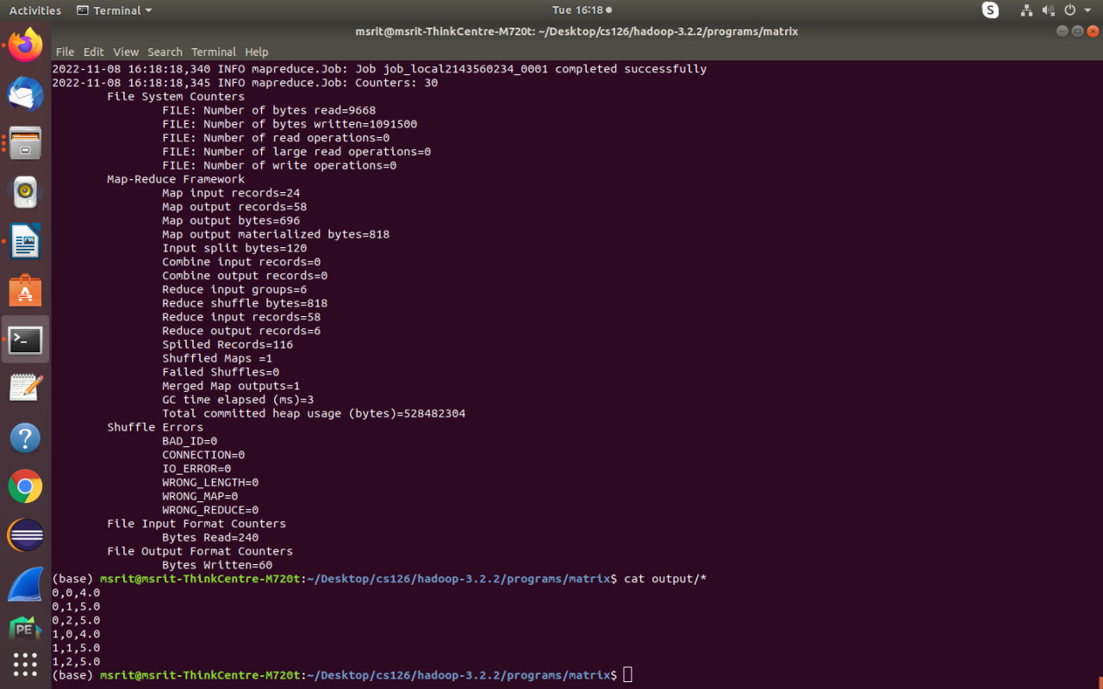

8. WordCount

driver.java

package wordcount;

import java.io.*;
import java.util.*;
import org.apache.hadoop.mapred.*;
import org.apache.hadoop.io.*;
import org.apache.hadoop.fs.Path;

public class driver
{
public static void main(String args[]) throws Exception
{
JobConf conf=new JobConf(driver.class);
conf.setMapperClass(mapper.class);
conf.setReducerClass(reducer.class);
conf.setOutputKeyClass(Text.class);
conf.setOutputValueClass(IntWritable.class);
FileInputFormat.addInputPath(conf, new Path(args[0]));
FileOutputFormat.setOutputPath(conf , new Path(args[1]));
JobClient.runJob(conf);

}
}

mapper.java

package wordcount;
import java.io.*;
import java.util.*;
import org.apache.hadoop.mapred.*;
import org.apache.hadoop.io.*;

public class mapper extends MapReduceBase implements Mapper<LongWritable , Text , Text , IntWritable>
{
public void map(LongWritable key , Text value, OutputCollector<Text,IntWritable> output, Reporter r) throws IOException
{
String line[]=value.toString().split(" ");
for(String a:line){
output.collect(new Text(a),new IntWritable(1));
}
}
}

reducer.java

package wordcount;
import java.io.*;
import java.util.*;
import org.apache.hadoop.mapred.*;
import org.apache.hadoop.io.*;
class reducer extends MapReduceBase implements Reducer<Text , IntWritable , Text , IntWritable>
{
public void reduce(Text key,Iterator<IntWritable> value, OutputCollector<Text,IntWritable> output, Reporter r) throws IOException
{
int count=0;
while(value.hasNext())
{
count+=value.next().get();
}
output.collect(new Text(key),new IntWritable(count));
}

}

input.txt

HDFS is a storage unit of Hadoop
MapReduce is a processing tool of Hadoop

Steps to run

1. Create a New File named Bash.sh
2. Copy the Below code and Paste inside Bash.sh and save that File.
export JAVA_HOME=$(readlink -f $(which javac) | awk 'BEGIN {FS="/bin"} {print
$1}')
export PATH=$(echo $PATH):$(pwd)/bin
export CLASSPATH=$(hadoop classpath)
3. Execute the bash.sh File using following command source Bash.sh.
4. Verify JAVA_HOME variable to be set to Java Path and PATH variable has your USN
Hadoop Folder.If any previous PATH set to Hadoop Folder remove that inside .bashrc
file.
5. Verify Hadoop is Installed or not by executing hadoop command.if command gives
Information about Hadoop command then Hadoop is Successfully Installed.
6. Create a folder wordcount and move to that folder
7. Make the driver.java , mapper.java and reducer.java files
8. Compile all java files (driver.java mapper.java reducer.java)
javac -d . *.java
9. Set driver class in manifest
echo Main-Class: wordcount.driver > Manifest.txt
10. Create an executable jar file
jar cfm wordcount.jar Manifest.txt wordcount/*.class
11. Run the jar file
hadoop jar wordcount.jar data.txt output
- Where data.txt is the input file
12. To see the Output
cat output/*

Output Screenshot

